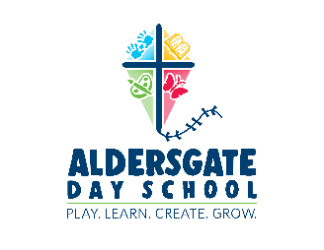

ALDERSGATE DAY SCHOOL

NEWCOMER REGISTRATION

OPENS JANUARY 3, 2022

- New Family applications will be accepted via email on a first come-first served basis beginning Monday, January 3, 2022. Completed wait list applications should be submitted online or emailed to dayschoolforms@aldersgate.net and will be time and date stamped upon arrival.

- All applications must be accompanied by a $10 wait list fee payable through:
- PayPal (to dayschool@aldersgate.net)

- All newcomer applicants will be placed on our Waiting List. Following Registration of returning Day School families and Aldersgate church members, vacancies will be filled from the Waiting List.

- You may expect to be contacted by Aldersgate in late January to inform you of available spaces. At that time you will be asked to secure your space by completing a Registration Application and submitting the registration fee ($100).

- If you haven’t heard from us by the end of January, don’t despair - vacancies will continue to be filled all the way up until school begins in September, and throughout the school year.

Thank you very much for your interest in Aldersgate Day School

